🛡️ Police Attendance Register – Working Explanation
1️⃣ Login Page
✅ How It Works:
- User enters Username and Password.
- Demo users like admin/admin123, officer/off123, staff/staff123 are available.
- When user clicks Sign In, the system validates credentials.
- After successful login, user is redirected to the Dashboard.

USER VALIDATION:
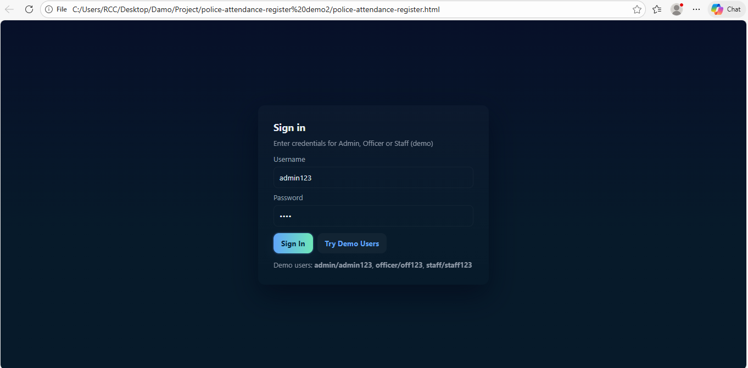

🎯 Purpose:
- Secure access control.
- Different roles (Admin, Officer, Staff).
- Prevent unauthorized access.

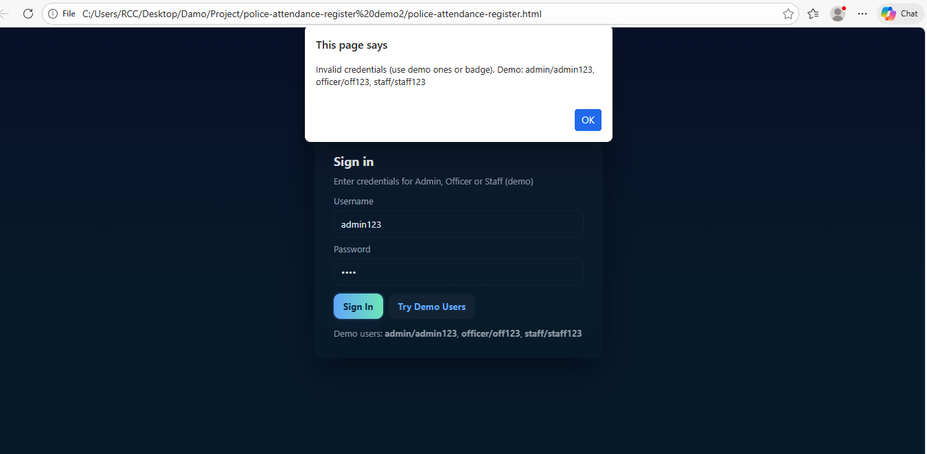

2️⃣ Dashboard Page
✅ How It Works:
After login, the Dashboard displays:
- Total Officers
- Today Present
- Pending Notifications
- Quick Action Buttons:
  - Mark Attendance
  - Register Officer
  - Generate Salary
It also shows:
- Latest Notifications
- System overview description
The data is fetched from internal storage and updated dynamically when actions are performed.
🎯 Purpose:
- Gives quick system summary.
- Allows fast access to important features.
- Central control panel for admin
- AFTER LOGGING IN:
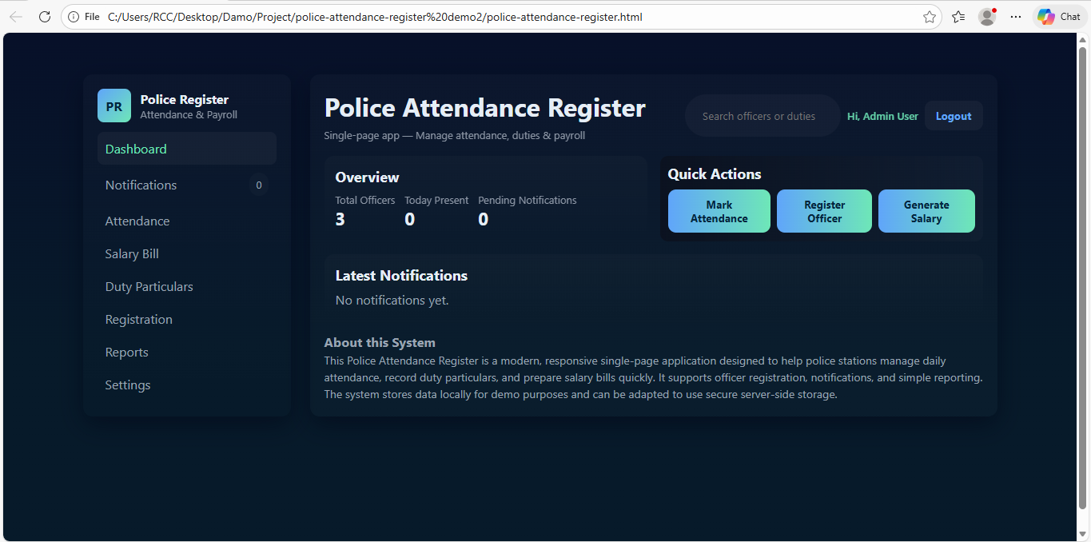

NOTIFICATION:
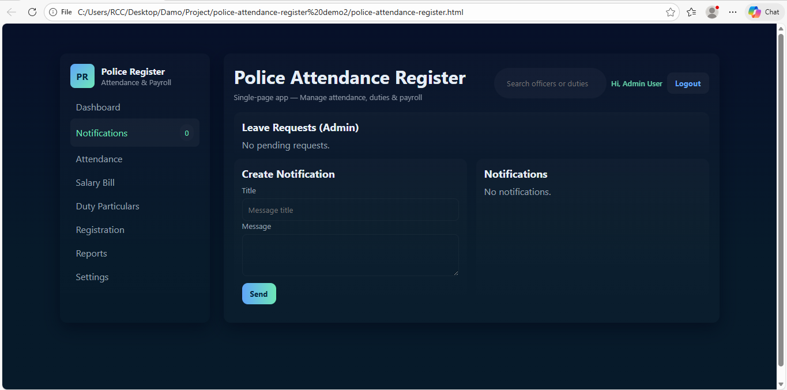

AFTER UPDATING NOTIFICATIONS:
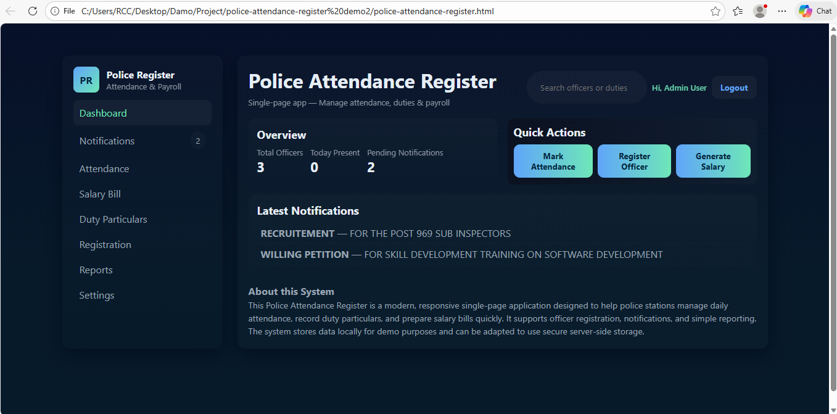

he Mark Attendance feature allows the admin or authorized officer to record daily attendance of police officers.
It helps in tracking:
- Present officers
- Absent officers
- Attendance date
- Duty status

⚙️ How It Works
1️⃣ User clicks “Mark Attendance” from the Dashboard or Attendance menu.
2️⃣ The system displays:
- List of registered officers
- Date (usually auto-filled with today’s date)
- Attendance options (Present / Absent / On Leave / Duty)
3️⃣ Admin selects attendance status for each officer.
4️⃣ After selecting, user clicks Save / Submit.
5️⃣ The system:
- Stores attendance data
- Updates Dashboard statistics
- Uses attendance data for salary calculation

🔄 What Happens After Marking Attendance?
- “Today Present” count increases on Dashboard.
- Attendance record is saved for reporting.
- Salary calculation uses attendance records.
- Reports section reflects updated data.

🎯 Purpose of Mark Attendance
✔ Maintain daily attendance record
✔ Track officer availability
✔ Support payroll calculation
✔ Monitor discipline and duty compliance
✔ Maintain digital record instead of manual register

MARKING ATTENDANCE
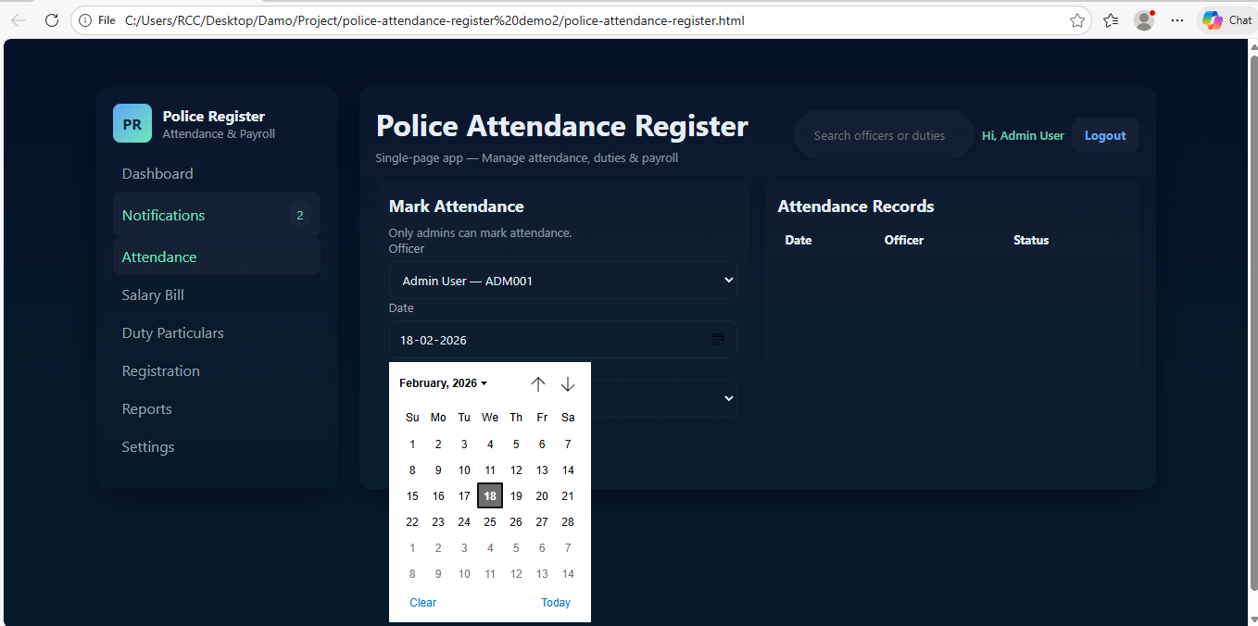

AFTER MARKING ATTENDANCE:

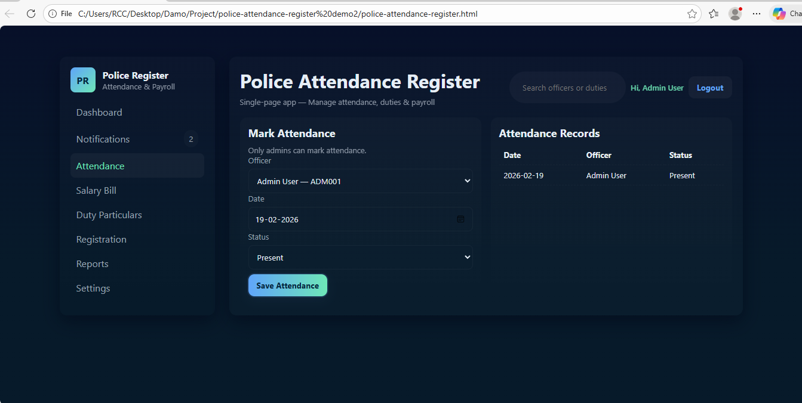

Salary Bill Page
✅ How It Works:
- Admin selects an Officer.
- Selects Month.
- Enters Base Pay.
- Clicks Generate.
The system:
- Calculates salary (based on attendance if implemented).
- Displays salary preview.
- Stores record for reporting.
🎯 Purpose:
- Manage payroll easily.
- Generate monthly salary bills.
- Keep salary records organized.

GENERATING SALARY

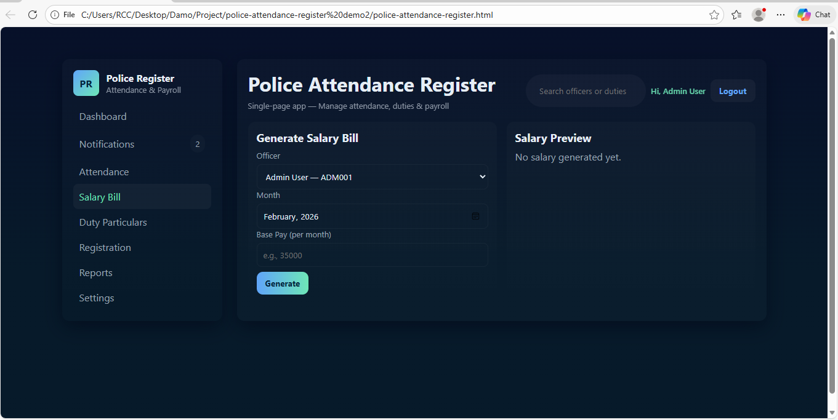
GENERATING SALARY ON BASIS OF ATTENDANCE, FOR 1 DAY WORKING IT IS CALCULATED AS 1300RS

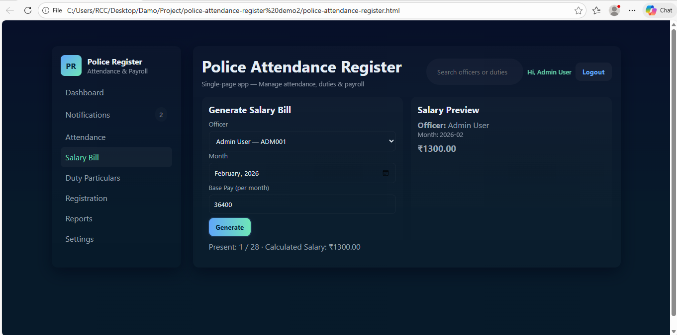

ASSIGNING DUTY
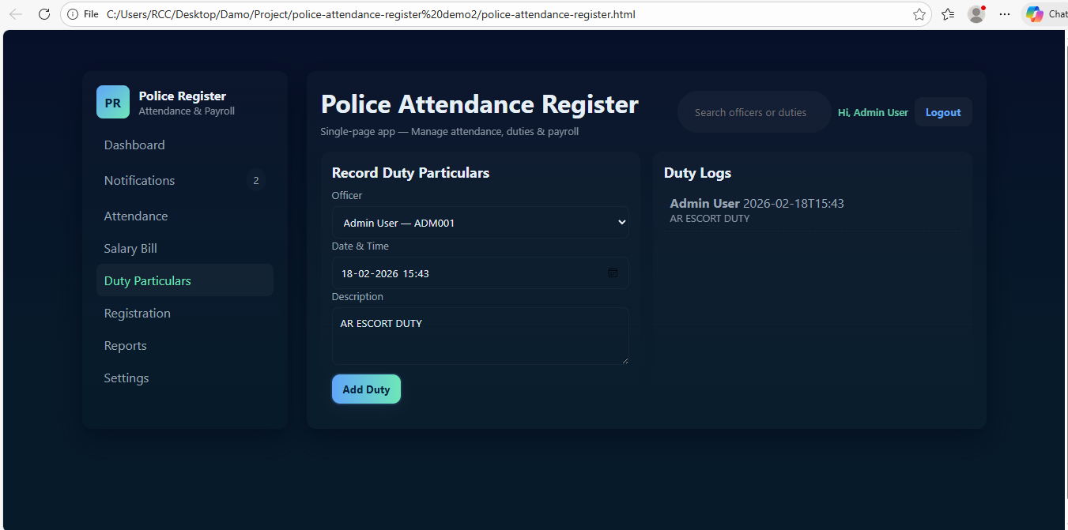

USER REQUESTING FOR REGISTRATION

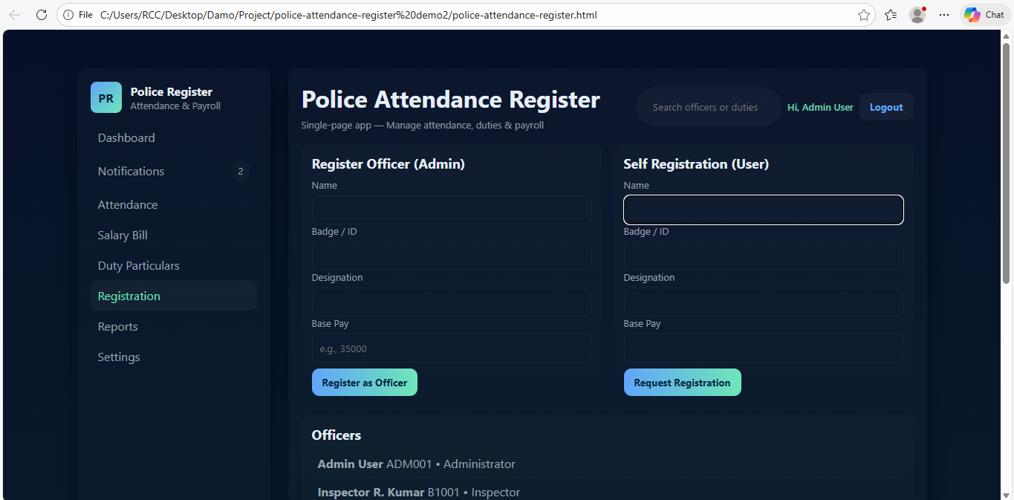

AFTER USER REGISTRATION

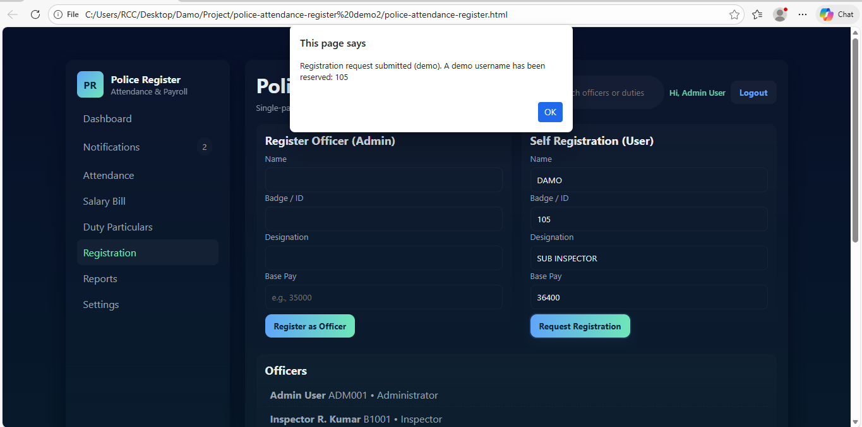

SUBMITTING LEAVE REQUEST

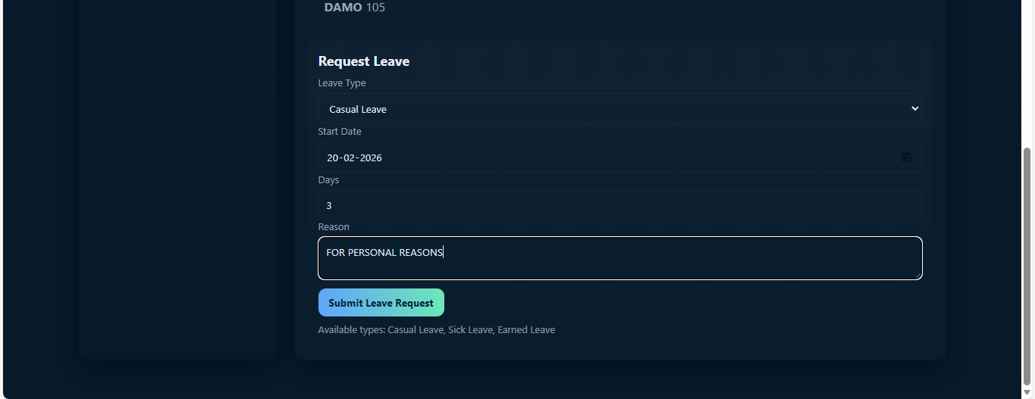

APPROVING LEAVE REQUEST FROM ADMIN SIDE:

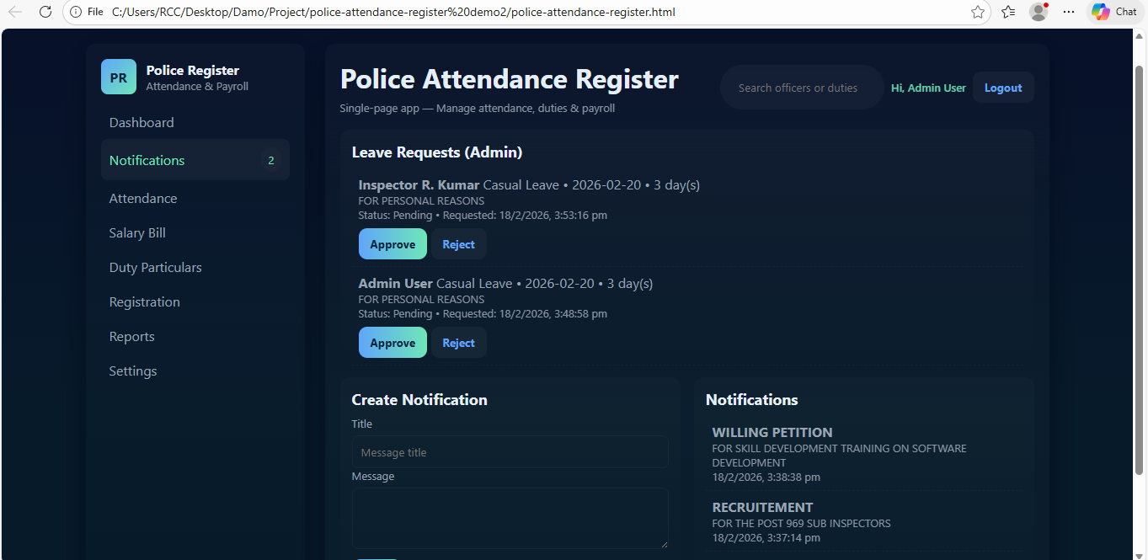

VIEWING FROM USER SIDE AFTER GOT LEAVE APPROVAL FROM ADMIN

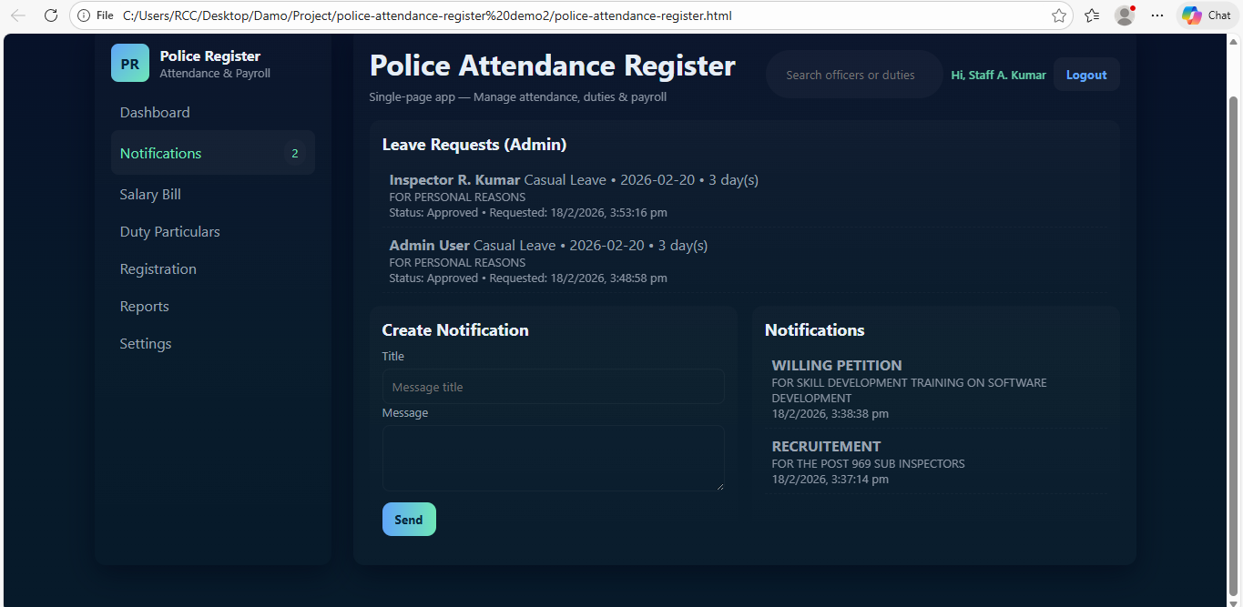

EXPORTING ATTENDANCE ON EXCEL FORMAT
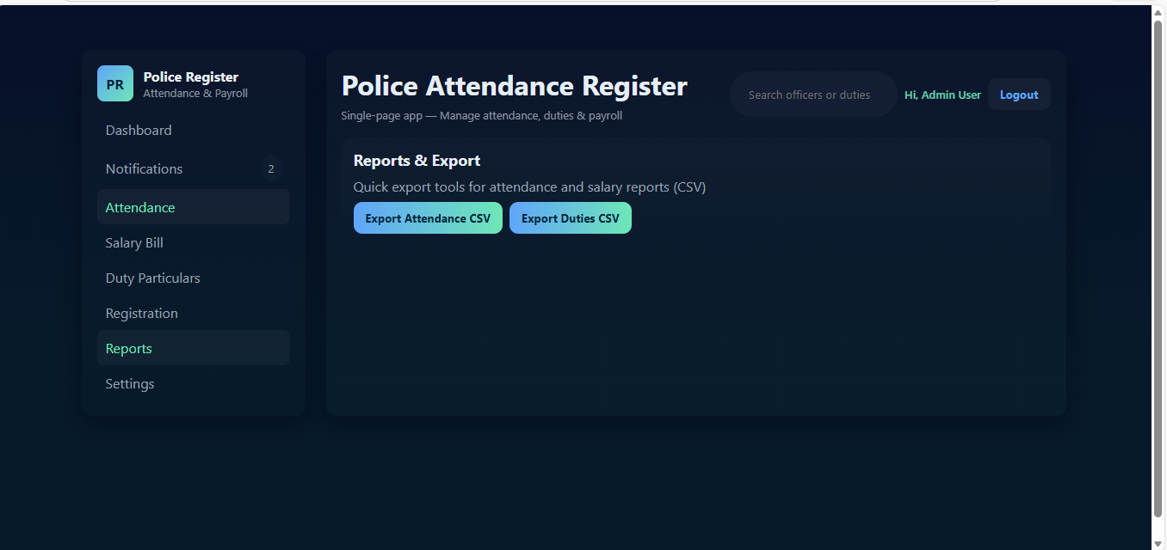

EXPORTED ATTENDANCE ON EXCEL FORMAT

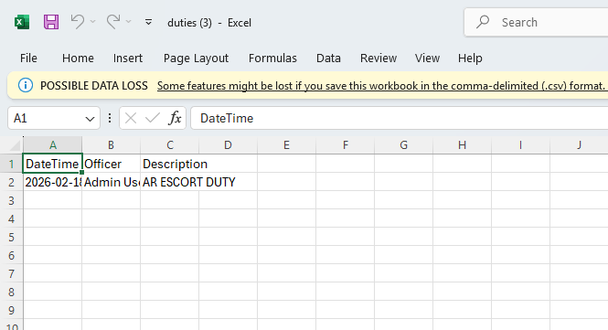
🔄 Overall Working Flow
- User logs in.
- Dashboard loads system summary.
- Admin registers officers.
- Marks daily attendance.
- Attendance data affects salary.
- Salary bill is generated.
- Reports can be viewed.
- Settings manage system preferences.

⚙️ Technical Working (Simple)
- Single-page application (SPA).
- Data stored locally (for demo).
- JavaScript handles dynamic updates.
- Responsive dark theme UI.
- Role-based login system.

🏁 Conclusion
This system helps police stations:
✔ Manage attendance
✔ Register officers
✔ Track duties
✔ Generate salary bills
✔ View reports
✔ Maintain records digitally
It is a modern, responsive attendance & payroll management system.

